SIMATS ENGINEERING
ASSESSMENT TOOL 1

COURSE NAME: CSA16 COURSE CODE: Data Warehousing and Data Mining

COURSE OUTCOME COVERED
CO3: Evaluate the effectiveness of classification techniques on real-time data for accurate prediction, enabling informed decision-making. (BL3,BL4,BL5)

QUESTIONS: 5 Total Marks:50
Annexure A
Experiments
Criteria | Understandin g of Concepts (2.5) | Experimental  Design (3) | Use of  Tools  (2) | Analysis of  Results (1.5) | Documentation  (1) | Total(10  )
Weightag e | 25% | 30% | 20% | 15% | 10% | 100%
Q1
Q2
Q3
Q4
Q5

Code of Conduct:
I Uppu Sye Kumar/192325121 (Name / Reg No) certify that this submission is my original work and that I have adhered to the guidelines specified for this assessment.
I understand that any violation of academic integrity rules will result in disciplinary action.
Signature of the student:U.SyeKumar
RUBRICS FOR CALCULATION:
Criteria | Weightage | Level 4 – Exemplary | Level 3 – Proficient | Level 2 –  Developing | Level 1 – Beginning
Understanding of Concepts | 25 | Demonstrates thorough understanding and  effectively integrates multiple concepts/technologies | Good understanding with proper  integration of most concepts | Basic understanding; limited or partial integration | Poor understanding; unable to integrate concepts
Experimental Design | 30 | Well-planned, systematic implementation with optimal solution | Correct implementation with minor issues | Basic implementation  with errors or inefficiencies | Incorrect or incomplete implementation
Use of Tools | 20 | Effective and advanced use of tools/technologies with proper configuration | Appropriate use of tools with correct execution | Limited or inconsistent use of tools | Incorrect or minimal use of tools
Analysis of Results | 15 | Insightful analysis with accurate interpretation and validation of results | Good analysis with reasonable  interpretation | Basic analysis with limited insights | Poor or incorrect analysis of results
Documentatio n | 10 | Clear, well-structured documentation with diagrams, code, and  results | Organized documentation with necessary details | Basic documentation  with missing details | Poor or incomplete documentation
Annexure C

Experiments :
Children of three ages are asked to indicate their preference for three photographs of adults. Do the data suggest that there is a significant relationship between age and photograph preference? What is wrong with this study? (10 Marks)
Photograph:
Age of child A B C
5-6 years: 18 22 20
7-8 years: 2 28 40
9-10 years: 20 10 40
Use cov() to calculate the sample covariance between B and C.
Use another call to cov() to calculate the sample covariance matrix for the preferences.
Use cor() to calculate the sample correlation between B and C.
Use another call to cor() to calculate the sample correlation matrix for the preferences.

Age and Photograph Preference
Children of three age groups were asked to indicate their preference for three photographs. The question requires covariance, correlation, and a test of the relationship between age and photograph preference.
Age of Child | Photograph A | Photograph B | Photograph C
5–6 years | 18 | 22 | 20
7–8 years | 2 | 28 | 40
9–10 years | 20 | 10 | 40
R Program
pref <- data.frame(
A = c(18, 2, 20),
B = c(22, 28, 10),
C = c(20, 40, 40)
)
cov(pref$B, pref$C)
cov(pref)
cor(pref$B, pref$C)
cor(pref)
age_photo <- matrix(
c(18,22,20,
2,28,40,
20,10,40),
nrow = 3,
byrow = TRUE
)
chisq.test(age_photo)
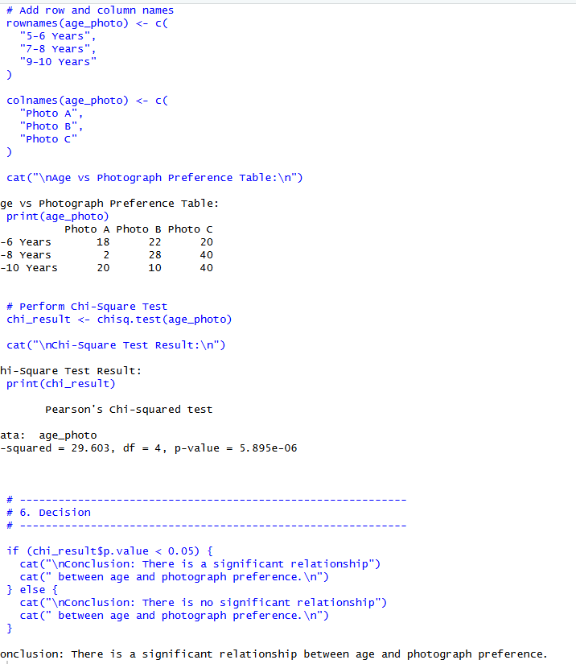

Results
Covariance between B and C = -20.
 | A | B | C
A | 97.33 | -74.00 | -46.67
B | -74.00 | 84.00 | -20.00
C | -46.67 | -20.00 | 133.33
Correlation between B and C ≈ -0.189, indicating a weak negative correlation.
 | A | B | C
A | 1.000 | -0.818 | -0.410
B | -0.818 | 1.000 | -0.189
C | -0.410 | -0.189 | 1.000
Chi-square test: χ² ≈ 29.603, df = 4, p ≈ 5.895 × 10⁻⁶.
Since p < 0.05, the null hypothesis is rejected. Therefore, there is a statistically significant relationship between age group and photograph preference.

- Assume the Tennis coach wants to determine if any of his team players are scoring outliers. To visualize the distribution of points scored by his players, then how can he decide to develop the box plot? (10 Marks)
Player ID Player Name Points Scored
P1 |  | Player A |  | 12
P2 |  | Player B |  | 15
P3 |  | Player C |  | 14
P4 |  | Player D |  | 10
P5 |  | Player E |  | 18
P6 |  | Player F |  | 20
P7 |  | Player G |  | 22
P8 |  | Player H |  | 13
P9 |  | Player I |  | 11
P10 |  | Player J |  | 35
 | P11 |  | Player K |  | 16
 | P12 |  | Player L |  | 17
 | P13 |  | Player M |  | 19
 | P14 |  | Player N |  | 21
 | P15 |  | Player O |  | 23

Box Plot for Tennis Players' Scores
A tennis coach wants to identify outliers in the points scored by team players using a box plot.
Player ID | Player Name | Points Scored
P1 | Player A | 12
P2 | Player B | 15
P3 | Player C | 14
P4 | Player D | 10
P5 | Player E | 18
P6 | Player F | 20
P7 | Player G | 22
P8 | Player H | 13
P9 | Player I | 11
P10 | Player J | 35
P11 | Player K | 16
P12 | Player L | 17
P13 | Player M | 19
P14 | Player N | 21
P15 | Player O | 23
R Program
points <- c(12,15,14,10,18,20,22,13,11,35,16,17,19,21,23)
boxplot(points,
main = "Boxplot of Tennis Players' Points",
ylab = "Points Scored")
summary(points)
Calculation
Sorted data: 10, 11, 12, 13, 14, 15, 16, 17, 18, 19, 20, 21, 22, 23, 35
Measure | Value
Q1 | 13.5
Median | 17
Q3 | 20.5
IQR | 7
Upper outlier boundary | 31
Since 35 > 31, the score of 35 is an outlier.
Result: Player J, with 35 points, is identified as an outlier.
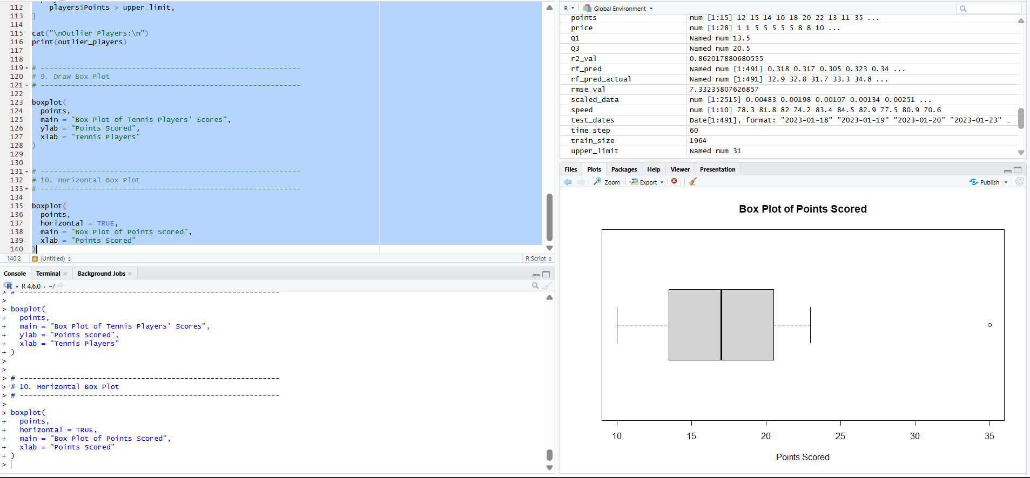

- A bank wants to decide whether to approve a loan based on customer attributes like:
  - Age
  - Income
  - Employment Status
  - Credit Score
Using historical data, build a Decision Tree classifier to predict Loan Approval (Yes/No).
(10 Marks)
Consider the Data Set young,high,employed,good,yes young,high,self-employed,average,yes middle,high,employed,good,yes old,medium,employed,good,yes old,low,unemployed,poor,no old,low,self-employed,average,no middle,low,unemployed,poor,no young,medium,employed,average,yes young,low,unemployed,poor,no old,medium,self-employed,good,yes middle,medium,employed,average,yes middle,high,self-employed,good,yes old,medium,unemployed,poor,no young,medium,self-employed,average,yes middle,low,employed,poor,no

Decision Tree Classifier for Loan Approval
The bank wants to predict Loan Approval (Yes/No) using Age, Income, Employment Status, and Credit Score.
Age | Income | Employment | Credit | Loan
young | high | employed | good | yes
young | high | self-employed | average | yes
middle | high | employed | good | yes
old | medium | employed | good | yes
old | low | unemployed | poor | no
old | low | self-employed | average | no
middle | low | unemployed | poor | no
young | medium | employed | average | yes
young | low | unemployed | poor | no
old | medium | self-employed | good | yes
middle | medium | employed | average | yes
middle | high | self-employed | good | yes
old | medium | unemployed | poor | no
young | medium | self-employed | average | yes
middle | low | employed | poor | no
R Program
library(rpart)
library(rpart.plot)
data <- data.frame(
Age = c("young","young","middle","old","old","old","middle",
"young","young","old","middle","middle","old","young","middle"),
Income = c("high","high","high","medium","low","low","low",
"medium","low","medium","medium","high","medium","medium","low"),
Employment = c("employed","self-employed","employed","employed",
"unemployed","self-employed","unemployed","employed",
"unemployed","self-employed","employed","self-employed",
"unemployed","self-employed","employed"),
Credit = c("good","average","good","good","poor","average","poor",
"average","poor","good","average","good","poor","average","poor"),
Loan = c("yes","yes","yes","yes","no","no","no","yes","no","yes",
"yes","yes","no","yes","no")
)
data$Age <- factor(data$Age)
data$Income <- factor(data$Income)
data$Employment <- factor(data$Employment)
data$Credit <- factor(data$Credit)
data$Loan <- factor(data$Loan)
model <- rpart(Loan ~ Age + Income + Employment + Credit,
data = data, method = "class")
rpart.plot(model)
pred <- predict(model, data, type = "class")
table(Actual = data$Loan, Predicted = pred)
mean(pred == data$Loan)
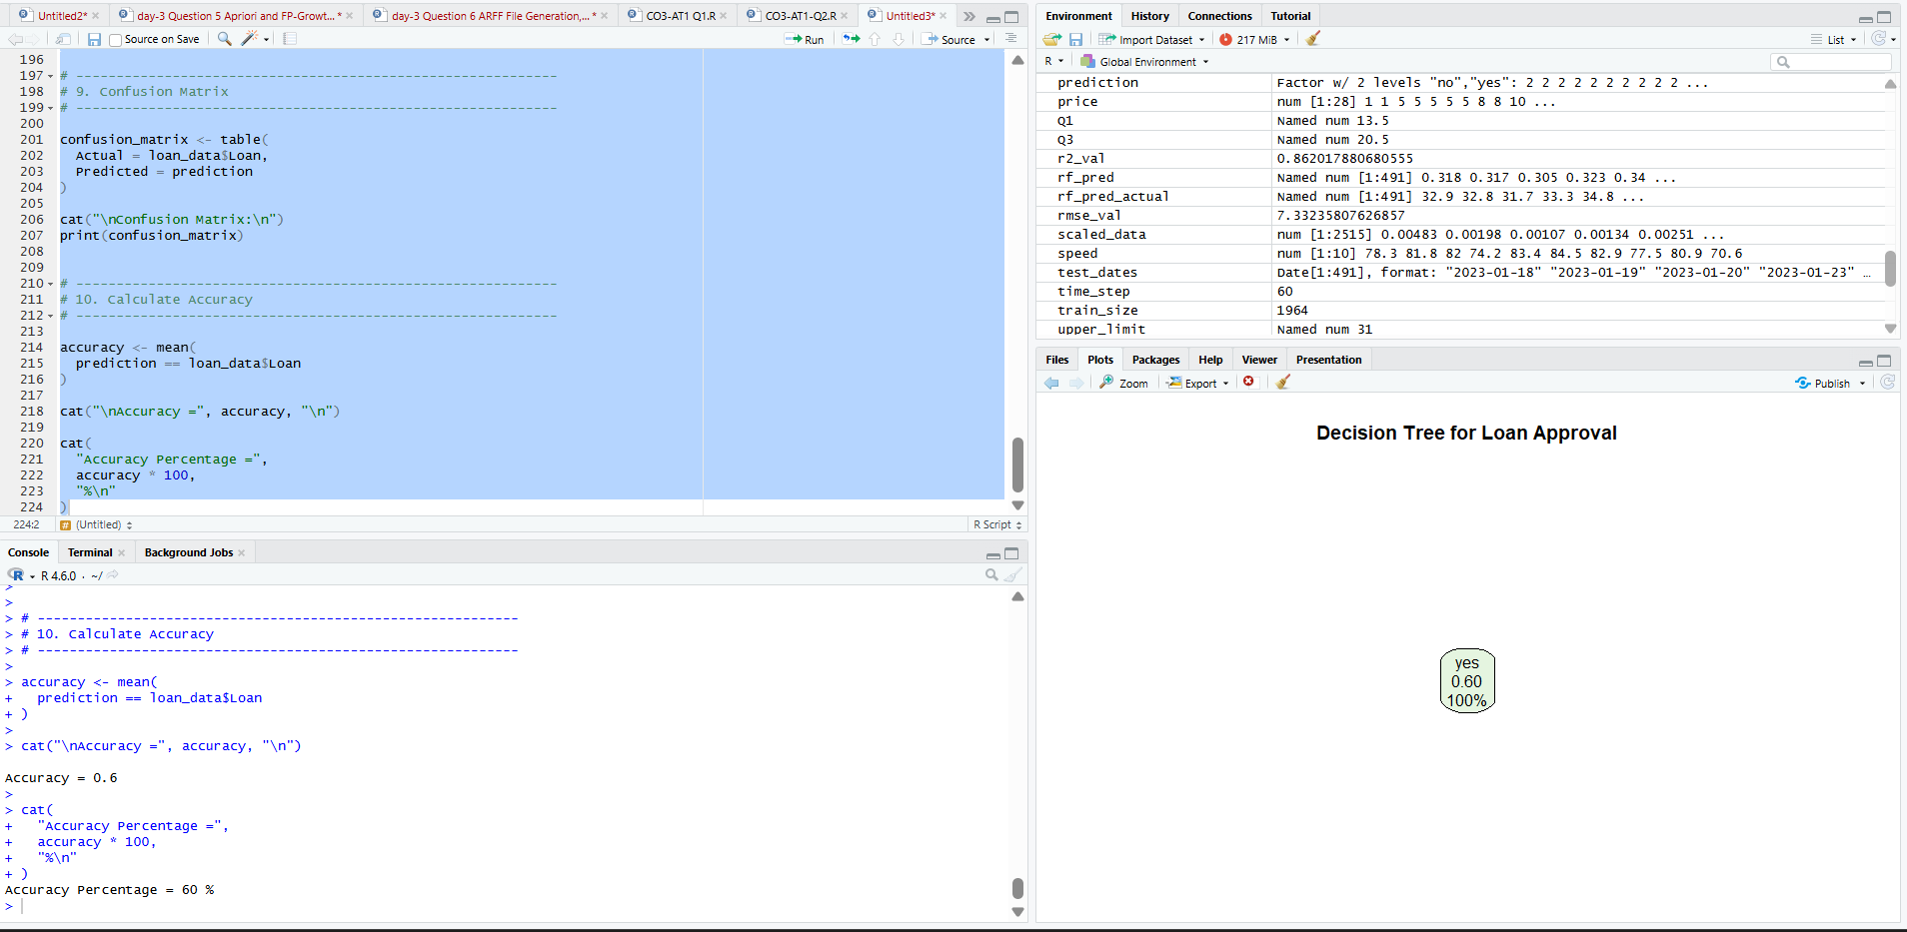
Result
The Decision Tree classifier learns the relationship between customer attributes and loan approval. Credit Score is a key attribute in determining the approval decision. The trained tree can be used to classify new customers as likely to be approved or rejected.

- Two Maths teachers are comparing how their Year 9 classes performed in the end of year exams. Their results are as follows: (5 Marks)
Class A: 76, 35, 47, 64, 95, 66, 89, 36, 8476,35,47,64,95,66,89,36,84 Class B: 51, 56, 84, 60, 59, 70, 63, 66, 5051,56,84,60,59,70,63,66,50 (i) Find which class had scored higher mean, median and range. (ii) Plot above in boxplot and give the inferences
Comparison of Maths Classes
The two Year 9 classes have the following examination marks.
Class | Marks
Class A | 76, 35, 47, 64, 95, 66, 89, 36, 84
Class B | 51, 56, 84, 60, 59, 70, 63, 66, 50
(i) Mean, Median and Range
classA <- c(76,35,47,64,95,66,89,36,84)
classB <- c(51,56,84,60,59,70,63,66,50)
mean(classA)
median(classA)
diff(range(classA))
mean(classB)
median(classB)
diff(range(classB))
Measure | Class A | Class B
Mean | 65.78 | 62.11
Median | 66 | 60
Range | 60 | 34
Class A has the higher mean and median. Class A also has the larger range, indicating greater variation.
(ii) Box Plot
boxplot(classA, classB,
names = c("Class A", "Class B"),
main = "Comparison of Class A and Class B",
ylab = "Exam Marks")
Inference: Class A performed better overall based on mean and median, whereas Class B showed more consistent performance because its marks have a smaller range.
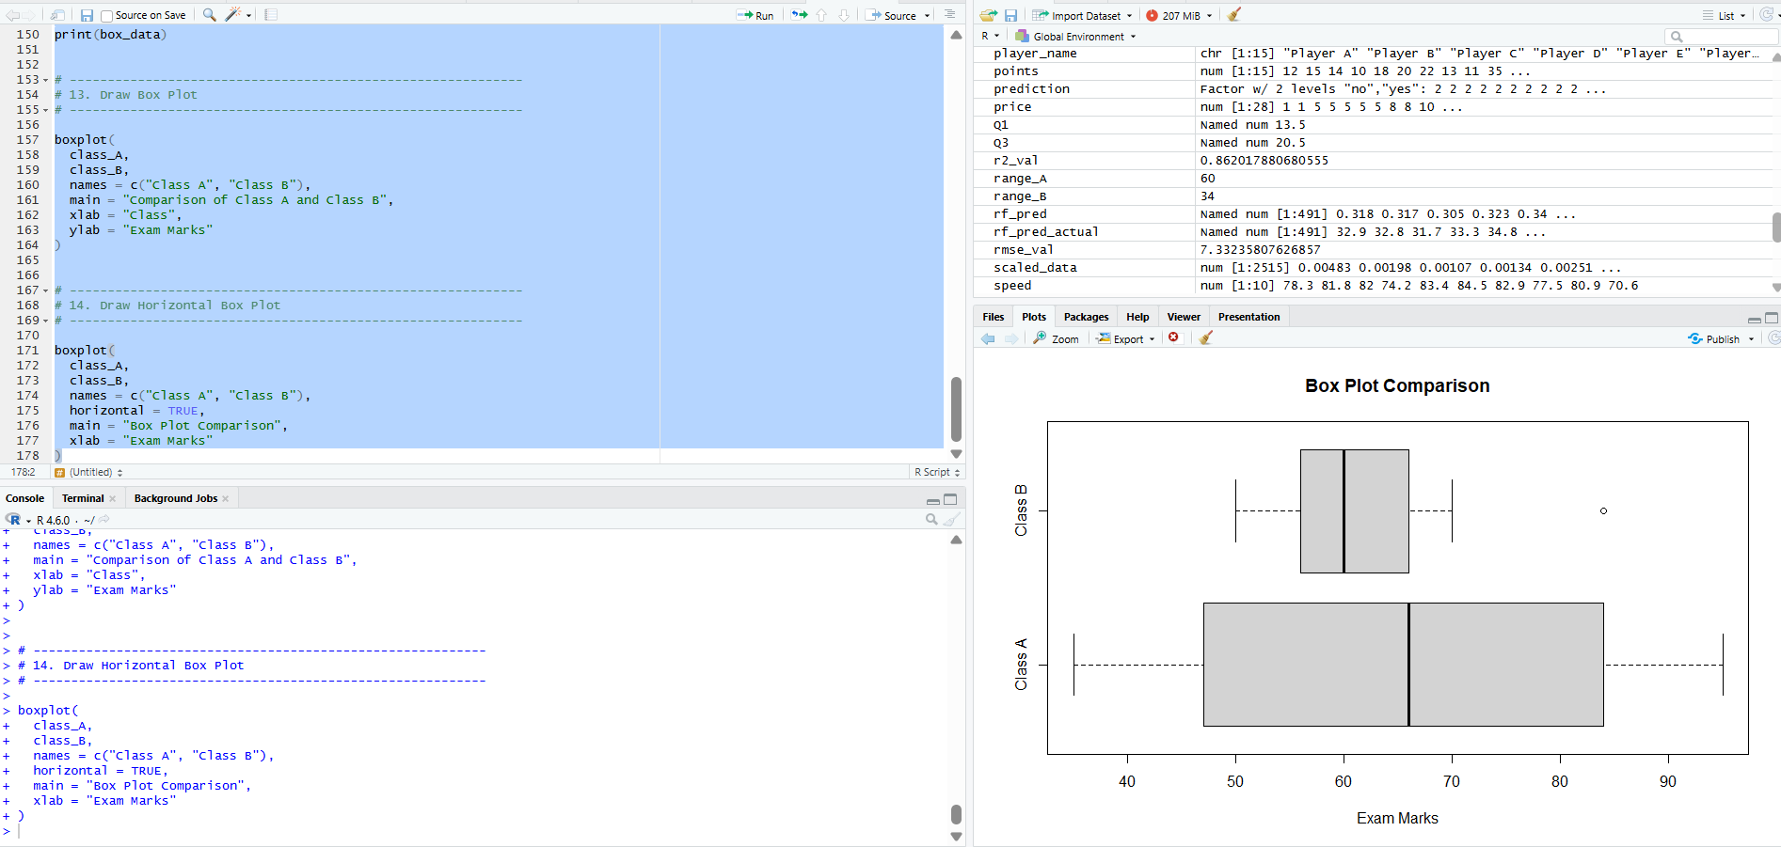

- Suppose that a hospital tested the age and body fat data for 18 randomly selected adults with the following results: (10 Marks)
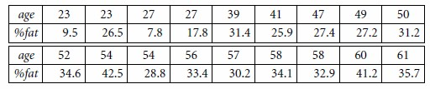
- Calculate the mean, median, and standard deviation of age and %fat.
- Draw the boxplots for age and %fat.
- Draw a scatter plot and a q-q plot based on these two variables.

Age and Body Fat Analysis
The hospital data contains age and percentage body-fat values for 18 randomly selected adults.
Age | % Fat
23 | 9.5
23 | 26.5
27 | 7.8
27 | 17.8
39 | 31.4
41 | 25.9
47 | 27.4
49 | 27.2
50 | 31.2
52 | 34.6
54 | 42.5
54 | 28.8
56 | 33.4
57 | 30.2
58 | 34.1
58 | 32.9
60 | 41.2
61 | 35.7
(a) Mean, Median and Standard Deviation
age <- c(23,23,27,27,39,41,47,49,50,52,54,54,56,57,58,58,60,61)
fat <- c(9.5,26.5,7.8,17.8,31.4,25.9,27.4,27.2,31.2,
34.6,42.5,28.8,33.4,30.2,34.1,32.9,41.2,35.7)
mean(age)
median(age)
sd(age)
mean(fat)
median(fat)
sd(fat)
Measure | Age | % Fat
Mean | 46.44 | 28.78
Median | 51.00 | 30.70
Standard Deviation | 13.22 | 9.25
Minimum | 23 | 7.8
Maximum | 61 | 42.5
The average age is approximately 46.44 years and the average body fat is approximately 28.78%. The standard deviations indicate the amount of variation in the two variables.
(b) Boxplots for Age and % Fat
boxplot(age,
main = "Boxplot of Age",
ylab = "Age")
boxplot(fat,
main = "Boxplot of Body Fat",
ylab = "% Body Fat")
The boxplots display the median, interquartile range, overall spread, and possible outliers. The data do not show obvious extreme outliers under the standard 1.5 × IQR rule.
(c) Scatter Plot
plot(age, fat,
main = "Age vs Body Fat",
xlab = "Age",
ylab = "% Body Fat",
pch = 19)
abline(lm(fat ~ age), lty = 2)
The scatter plot shows a positive relationship between age and body fat. The correlation is approximately r = 0.818, indicating a strong positive linear association in this sample.
Q-Q Plot
qqnorm(age, main = "Q-Q Plot of Age")
qqline(age)
qqnorm(fat, main = "Q-Q Plot of Body Fat")
qqline(fat)
Q-Q plots are used to assess whether the variables approximately follow a normal distribution. Points close to the reference line indicate approximate normality, while large departures indicate deviation.
